**MISSING SHIP DETECTION ON WATER BODIES**

## *A Project Report submitted in partial fulfillment of the*

***requirements for the award of the degree of***

## Bachelor of Technology in Computer Science & Engineering

***By***

***ESRAMONI MOUNIKA 20951A0593***

***VISHWA NETHRA 20951A0576***

***K. JAYANTH SAI 20951A0564***



**Department of Computer Science and Engineering**

# INSTITUTE OF AERONAUTICAL ENGINEERING

**(Autonomous)**

**Dundigal, Hyderabad – 500 043, Telangana**

**DECEMBER, 2023**

@2023, Esramoni Mounika, Angari Maheshwara Vishwa Nethra, K.Jayanth Sai

All rights reserved

**MISSING SHIP DETECTION ON WATER BODIES**

***ESRAMONI MOUNIKA 20951A0593***

***ANGARI VISHWA NETHRA 20951A0576***

***K. JAYANTHI SAI 20951A0564***

**MISSING SHIP DETECTION ON WATER BODIES**

**DECLARATION**

I certify that

1. the work contained in this report is original and has been done by me under the guidance of my supervisor(s).
2. the work has not been submitted to any other Institute for any degree or diploma.
3. I have followed the guidelines provided by the Institute in preparing the report.
4. I have conformed to the norms and guidelines given in the Ethical Code of Conduct of the Institute.
5. whenever I have used materials (data, theoretical analysis, figures, and text) from other sources, I have given due credit to them by citing them in the text of the report and giving their details in the references. Further, I have taken permission from the copyright owners of the sources, whenever necessary.

**Place: Hyderabad Signature of the Student**

**Date: 28-12-2023 Roll No:20951A0593**

**20951A0576**

**20951A0564**

## CERTIFICATE

This is to certify that the project report entitled **MISSING SHIP DETECTION ON WATER BODIES** submitted by **ESRAMONI MOUNIKA, ANGARI MAHESHWARA VISHWA NETHRA, K. JAYANTH SAI** to the Institute of Aeronautical Engineering, Hyderabad in partial fulfillment of the requirements for the award of the Degree Bachelor of Technology in **COMPUTER SCIENCE AND ENGINEERING** is a bonfire record of work carried out by him/her under my/our guidance and supervision. The contents of this report, in full or in parts, have not been submitted to any other Institute for the award of any Degree.

**Supervisor Head of the Department**

**Date:**

**APPROVAL SHEET**

This project report entitled **MISSING SHIP DETECTION ON WATER BODIES** by **ESRAMONI MOUNIKA, ANGARI MAHESHWARA VISHWA NETHRA, K. JAYANTH SAI** is approved for the award of the Degree Bachelor of Technology in **COMPUTER SCIENCE AND ENGINEERING.**

### Examiners

**Supervisor (s)**

**Date:**

**Place:**

**ACKNOWLEDGEMENT**

The satisfaction that accomplishes the successful completion of any task would be Without the mention of the people who made it possible and whose constant guidance and Encouragement crown all the efforts with success. I thank our college management and respected Sri Marri Rajasekhar Reddy, Chairman, Institute of Aeronautical Engineering College, Dundigal for providing me the necessary infrastructure to carry out the Project work. I express my sincere thanks to Dr. L. V. Narasimha Prasad, Professor and Principal who has been a great source of information for my work and Dr. C Madhusudhana Rao, Professor and Head, Department of CSE, for extending her support to carry on this project work. I am especially thankful to our supervisor Dr. D. Durga Bhavani, Assistant Professor, Department of CSE for his internal support and professionalism who helped me in shaping the project into successful one. I take this opportunity to express my thanks to one and all directly helped me in bringing this effort to present form

**ABSTRACT**

The detection of ships is an essential task for a large variety of applications in both military and civilian fields. This study proposes a ship detection method from images taken at ocean and sea using Artificial Neural Network (ANN) and Convolutional Neural Network (CNN). Detection of Ships is very much important for the safe operation of ships and enables collision avoidance. In War, It is very helpful for finding other countries' ships that are closer to our territories. Detection of ships is complicated, especially under unfavourable conditions, such as during night time or cloudy days. Here we are using satellite images of ships. We will try to detect a Ship with Maximum Accuracy using ANN, CNN, and other approaches. Ship Detection is a process of identifying whether a Ship is present in a given image or not

States have an increasingly pressing need to effectively use and control marine waterways in the commercial and military domain. For this reason, there are a few reasons:

Detecting lost ships, boats, or debris in the ocean; preventing the use of ship anchoring areas illegally; monitoring fishing activities to prevent illegal fishing or protect fish populations; and identifying and locating warships (intelligence, defence, offensive, etc.). This research suggested an open source, quick ship detection system using a deep learning algorithm on optical satellite photos.

The system can function with standard laptop hardware and doesn't require any complex technology. Optical satellite photos of ships are used to train the Tensorflow Object Detection Application Programming Interface (API).

**Keywords**: ship detection, optical satellite image, deep learning, TensorFlow, python, artificial neural networks

**CONTENTS**

|  |  |  |
| --- | --- | --- |
| Title Page |  | I |
| Declaration | | II |
| Certificate |  | III |
| Approval |  | IV |
| Acknowledgement | | V |
| Abstract |  | VI |
| Contents |  | VII |
| Chapter 1 | Introduction | 1 |
|  | 1.1 Introduction | 1 |
|  | 1.2 Existing Solution | 2 |
|  | 1.3 Proposed Solution | 2 |
| Chapter 2 | Review of Relevant Literature | 3 |
| Chapter 3 | Methodology | 5 |
| Chapter 4 | Used algorithms | 6 |
| Chapter 5  Chapter 6  Chapter 7 | Source Code  Results and Discussions  Conclusion and Future Scope of Study | 9  1  14 |
| References |  | 15 |

**CHAPTER 1**

**INTRODUCTION**

* 1. **Introduction**

The collected Satellite images provide a large coverage extending across water-covered areas, making possible continuous observation of ship locations. The detection of ships has been an active research topic. There are many ship detection methods that have been there but this still constitutes a challenge due to uncertain conditions like cloud cover, the density of ships, and so on. Here Satellite data or Satellite images have shown great value for monitoring the Ship’s Detection.

In recent years, many traditional ship detection methods have been proposed. Different methods work on different Ideologies some methods use the idea of sea-land segmentation to extract sea regions. Generally, the detection delivers satisfactory or expected results under normal conditions where ships are at a certain distance from each other. Under challenging conditions as mentioned above, this method can’t deliver the expected results.

In recent years, tremendous progress in ship detection and classification has been made using Artificial Neural network (ANN) and convolutional Neural Network (CNN). Here in oIXur progress, we are using these two methods for detecting the ship and we will check which method gives satisfactory or expected results. For implementing these two methods we have to Load and reshape data, Data visualization, Pixel Intensity, channel 6 view, and Modelling then ANN Implementation and CNN Implementation.

In order to address these concerns, the observer can visit the affected areas and conduct direct checks, but doing so will take time and put them in grave danger in the event of terrorism or conflict. synthetic aperture radar (SAR) imagery can all be used to examine the sea's surface. Active transmission devices can put observers in danger during a fight since they allow enemy electronic warfare systems to determine your coordinates based on the transmission. It is never desirable to do this in a war situation. in order to make gadgets like satellite imagery and video cameras far more beneficial. In contrast to the Osman Duman Department of Electronics and Communication Engineering

**EXISTING SYSTEM**

With the rise of autonomous vehicles, autonomous ships have attracted more attention, especially for long-distance and short-distance cargo ships and special ships participating in high-risk military operations. Some ships are equipped with automatic identification systems (AISs) and broadcast their own position and other information through radio signals, which can be received by surrounding ships to avoid collisions. However, little marine crafts (canoes, kayaks, sailboats, small fishing boats, etc.) are often not equipped with AIS and the signals emitted by AIS are vulnerable to interference. Therefore, for ship management in the marine environment and the unmanned and autonomous navigation of ships, the ability to accurately detect ships is needed**.**

**PROPOSED SYSTEM**

The exiting methods are Traditional ship detection methods which comprise the following steps: preprocessing, sea–sky line (SSL) detection, region of interest (ROI) extraction, and identification but these are helpful under normal circumstances. So to overcome all the problems we use this detection by using Artificial Neural Network and Convolutional Neural Network (CNN). To get the more accurate result we use the Convolutional Neural Network (CNN).

**CHAPTER 2**

**LITERATURE REVIEW**

**Mesut Kartal Dept. Electronics and Communication Engineering Istanbul Technical University Istanbul, Turkey**

The effective use and control of maritime routes in the commercial/military area is an increasing and important need for states. There are some motivations for this purpose: Safe traffic of the ships in narrow canals, avoiding illegal usage of anchoring areas of ships, monitoring fishing activities to avoid illegal fishing or protect fish population, detection of lost ships, boats or debris in the ocean, detection and identification of warships (intelligence, defense, offensive, etc.). This paper proposed an open source, fast running ship detection system from optical satellite images with the deep learning algorithm. The system does not need any comprehensive hardware, even can work on an average laptop. Tensorflow Object Detection Application Programming Interface (API) is trained by optical satellite images with ships and used as object detection API.

**Liu Z, Wang H, Weng H, Yang L (2016) Ship rotated bounding box space for ship extraction from high-resolution optical satellite images with complex backgrounds.**

Detection of maritime object is of greater attention in the field of satellite image processing applications in order to ensure the security and traffic control. Even though several approaches were built in the past few years, still it requires proper revamp in the architecture to focus toward the reduction of barriers to improve the performance of ship identification or appropriate vessel detection. The inference due to cluttered scenes, clouds, and islands in between the ocean is the greater challenge during the classification of ship or vessel. In this paper, we proposed a novel ship detection method called deep neural method which works very faster and based on the concept on deep learning methodology. Experimental results provide the better accuracy, and time complexity also reduces little further when compared to the traditional methodology.

**Zhu C, Zhou H, Wang R, Guo J (2010) A novel hierarchical method of ship detection from spaceborne optical image based on shape and texture feature**

Automatic ship detection on spaceborne optical images is a challenging task, which has attracted wide attention due to its extensive potential applications in maritime security and traffic control. Although some optical image ship detection methods have been proposed in recent years, there are still three obstacles in this task: 1) the inference of clouds and strong waves; 2) difficulties in detecting both inshore and offshore ships; and 3) high computational expenses. In this paper, we propose a novel ship detection method called SVD Networks (SVDNet), which is fast, robust, and structurally compact. SVDNet is designed based on the recent popular convolultional neural networks and the singular value decompensation algorithm. It provides a simple but efficient way to adaptively learn features from remote sensing images. We evaluate our method on some spaceborne optical images of GaoFen-1 and Venezuelan Remote Sensing Satellites. The experimental results demonstrate that our method achieves high detection robustness and a desirable time performance in response to all of the above three problems.

**Bi F, Zhu B, Gao L, Bian M (2012) A visual search inspired computational model for ship detection in optical satellite images**

In this letter, we propose a novel computational model for automatic ship detection in optical satellite images. The model first selects salient candidate regions across entire detection scene by using a bottom-up visual attention mechanism. Then, two complementary types of top-down cues are employed to discriminate the selected ship candidates. Specifically, in addition to the detailed appearance analysis of candidates, a neighbourhood similarity-based method is further exploited to characterize their local context interactions. Furthermore, the framework of our model is designed in a multiscale and hierarchical manner which provides a plausible approximation to a visual search process and reasonably distributes the computational resources. Experiments over panchromatic SPOT5 data prove the effectiveness and computational efficiency of the proposed mode

**CHAPTER 3**

**METHODOLOGY**

## 

**CHAPTER 4**

**USED ALGORITHMS**

**Artificial Neural Network (ANN**)

Input layer:

In neural networks independent variables are input. Here, we are taking the pixel values as input layers containing normalized RGB values. This input layer has a shape of a 3d matrix containing 2400 images.

Hidden layer:

In a neural network, the hidden layer consists of neurons. In these neurons we are doing two steps: weighted sum and activation function. In weighted sum we are drawing the best fit line using linear regression. So we can predict other images to know whether a ship is present or not. But using this weighted sum we are misclassifying some of the ships. So, we are using an activation function.

In the activation function we are using sigmoid or logit function. Using this sigmoid function we are getting better accurate results. Below, the given diagram depicts the neuron combination of weighted sum and activation function.

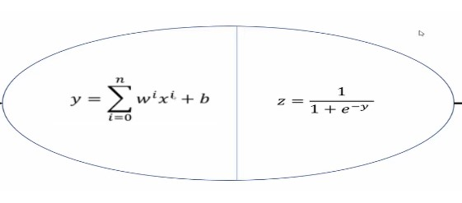

Fig 6.2 : - neuron combination of weighted sum and activation function

In our code we used a total of two hidden layers. In the first layer we used 200 neurons and in the second layer we used 150 neurons. We used relu function and sigmoid functions in the hidden layer.

Output layer:

In this output layer we are getting 1 or 0 whether the ship is present or not. We created an output layer using the sigmoid function from the model. After creating the output layer we are compiling our model using adam optimizer. Then we used the early back stopping if accuracy is decreasing. From these we are getting our output results.

**What is CNN?**

It is neural network with some mathematical operation between the layers. • Its main objective is to extract features from the image and learn all features from image that would help in object detection. CNN model consists of:-

1. Input layer

2. Convolution layer

3. Pooling layer

4. Fully Connected Layer

**Input layer**: - It contains the data of images in RGB format on which we are going to apply CNN

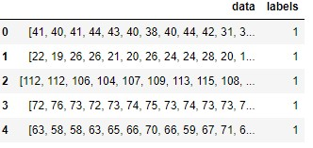

**Convolution layer** :- In this layer we apply filter on input layer to extract the important features of images. Its main objective is to extract features from images and learn all the features of the image which would help in image detection. The input layer contains some pixel value in RGB with some weight and height; the filter will convolve around input layer and will retrieve the important features with fewer dimensions.



**Pooling Layer** :- This layer is applied just after the convolution layer and it reduces the dimension of feature map which help in preventing the important features of input map from loss and reduces the computation time. Using pooling, a lower resolution version of input is created that still contains the large or important elements of the input image. Max pooling is used to reduce the parameters and helps to increase computation of our convolutional 21 model. Max-pooling extracts the maximum value from the filter. We perform pooling to reduce dimensionality.

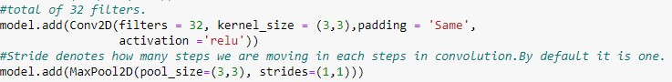

**Fully Connected Layer**:- Fully Connected Layer connects the information extracted from the Convolution layer and Pooling layers to the output layer and eventually classifies the input into the desired label.

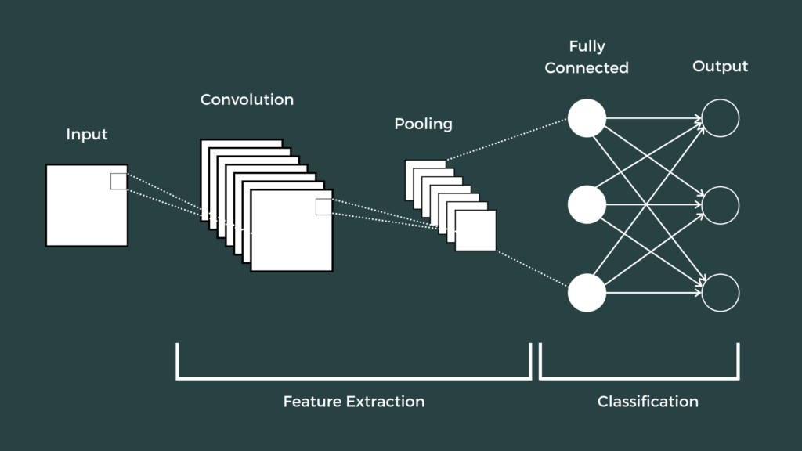

**CHAPTER 4**

**SOURCE CODE**

import numpy as np

from numpy import expand_dims

import pandas as pd

import json

import matplotlib.pyplot as plt

from sklearn.model_selection import train_test_split

from sklearn.model_selection import cross_val_score

from sklearn.metrics import confusion_matrix

from tensorflow.keras.utils import to_categorical

import keras

from keras import layers

from keras.wrappers.scikit_learn import KerasClassifier

from keras.models import Sequential

from keras.layers import Dense, Dropout, Flatten, Conv2D, MaxPool2D

from tensorflow.keras.optimizers import RMSprop,Adam

from keras.preprocessing.image import ImageDataGenerator

from keras.callbacks import EarlyStopping

len(shipsnet["data"].iloc[0])

ship_images = shipsnet["labels"].value_counts()[0]

no_ship_images = shipsnet["labels"].value_counts()[1]

print("Number of the ship_images :{}".format(ship_images),"\n")

print("Number of the no ship_images :{}".format(no_ship_images))

x = np.array(dataset['data']).astype('uint8')

y = np.array(dataset['labels']).astype('uint8')

x.shape

x_reshaped = x.reshape([-1, 3, 80, 80])

x_reshaped.shape

image_no_ship = x_reshaped[y==0]

image_ship = x_reshaped[y==1]

def plot(a,b):

plt.figure(figsize=(15, 15))

for i, k in enumerate(range(1,9)):

if i < 4:

plt.subplot(2,4,k)

plt.title('Not A Ship')

plt.imshow(image_no_ship[i+2])

plt.axis("off")

else:

plt.subplot(2,4,k)

plt.title('Ship')

plt.imshow(image_ship[i+15])

plt.axis("off")

plt.subplots_adjust(bottom=0.3, top=0.7, hspace=0.25)

#Implementation of the function

plot(image_no_ship, image_ship)

def plotHistogram(ship, not_ship):

plt.figure(figsize = (10,7))

plt.subplot(2,2,1)

plt.imshow(ship)

plt.axis('off')

plt.title('Ship')

histo = plt.subplot(2,2,2)

histo.set_ylabel('Count', fontweight = "bold")

histo.set_xlabel('Pixel Intensity', fontweight = "bold")

n_bins = 30

plt.hist(ship[:,:,0].flatten(), bins = n_bins, lw = 0, color = 'r', alpha = 0.5);

plt.hist(ship[:,:,1].flatten(), bins = n_bins, lw = 0, color = 'g', alpha = 0.5);

plt.hist(ship[:,:,2].flatten(), bins = n_bins, lw = 0, color = 'b', alpha = 0.5);

plt.show()

print("Minimum pixel value of this image: {}".format(ship.min()))

print("Maximum pixel value of this image: {}".format(ship.max()))

plt.figure(figsize = (10,7))

plt.subplot(2,2,3)

plt.imshow(not_ship)

plt.axis('off')

plt.title('Not A Ship')

histo = plt.subplot(2,2,4)

histo.set_ylabel('Count', fontweight = "bold")

histo.set_xlabel('Pixel Intensity', fontweight = "bold")

n_bins = 30

plt.hist(not_ship[:,:,0].flatten(), bins = n_bins, lw = 0, color = 'r', alpha = 0.5);

plt.hist(not_ship[:1].flatten(), bins = n_bins, lw = 0, color = 'g', alpha = 0.5);

plt.hist(not_ship[:,:,2].flatten(), bins = n_bins, lw = 0, color = 'b', alpha = 0.5);

plt. show ()

print("Minimum pixel value of this image: {}".format(not_ship.min()))

print("Maximum pixel value of this image: {}".format(not_ship.max()))

my_list = [(0, 'R channel'), (1, 'G channel'), (2, 'B channel')]

plt.figure(figsize = (15,15))

for i, k in my_list:

plt.subplot(1,3,i+1)

plt.title(k)

plt.ylabel('Height {}'.format(x_reshaped[y==0][5].shape[0]))

plt.xlabel('Width {}'.format(x_reshaped[y==0][5].shape[1]))

plt.imshow(x_reshaped[y==0][5][ : , : , i])

from keras import callbacks

# creating a neural network

model = Sequential()

# we are adding all the layers

# we are adding input layer

model.add(Flatten(input_shape=[80, 80, 3]))

# we are adding hidden layer relu has activation function

# genearal guide lines forhidden layer to add relu has activation function

# here 200 are neurons

# output layer has 1 and 0 so the activation is sigmoid

# Here 2 because getting output as 1 or 0

model.add(Dense(200, activation='relu'))

# another layer

model.add(Dense(150, activation='relu'))

model.add(Dense(2, activation='sigmoid'))

# we are compiling our model

# using adam as optimizer

model.compile(loss='categorical_crossentropy', optimizer='Adam', metrics=['accuracy'])

# if model is stopped improving then we are stopping it

earlystopping = callbacks.EarlyStopping(monitor ="val_loss",

mode ="min", patience = 10,

restore_best_weights = True)

**CHAPTER 5**

**RESULTS AND DISCUSSIONS**

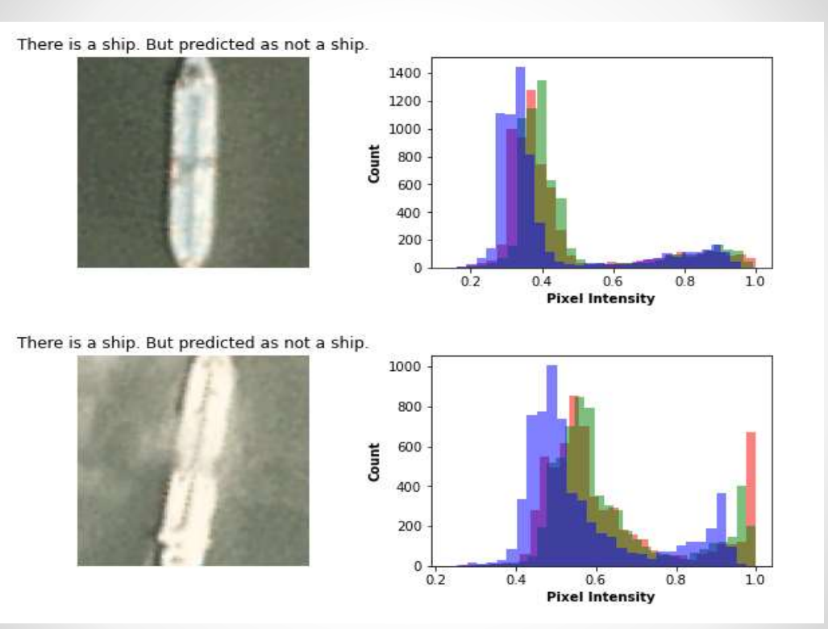

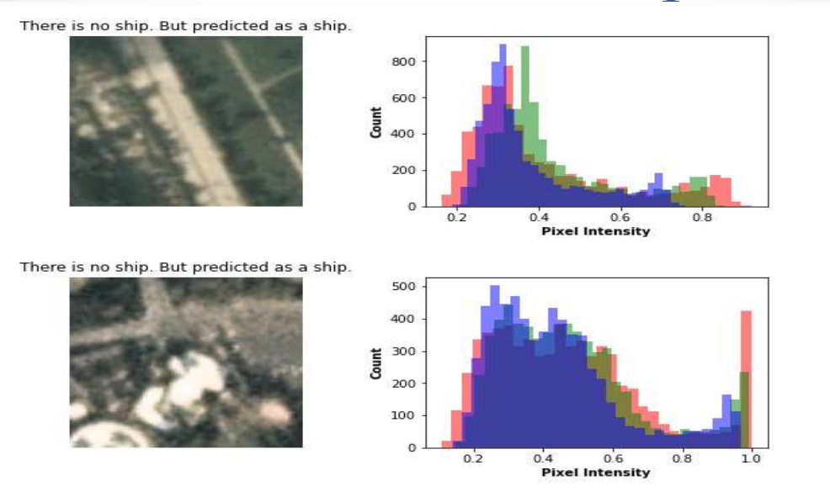

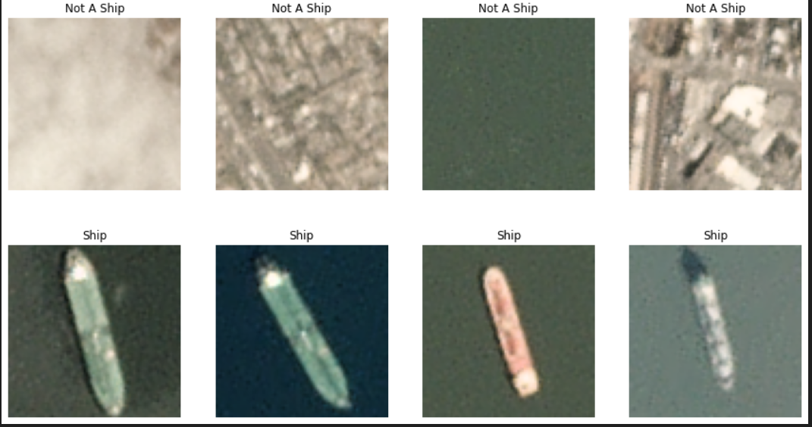

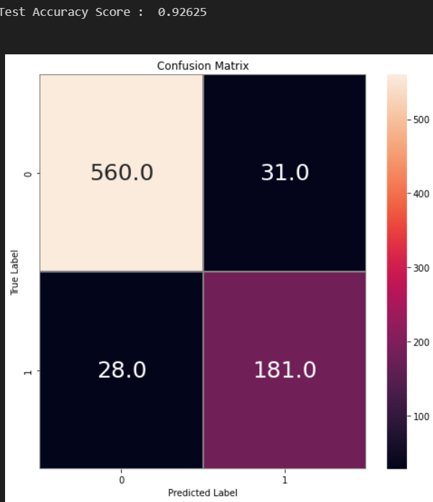

**CHAPTER 6**

**CONCLUSION AND FUTURE SCOPE OF STUDY**

After applying the ANN and CNN on the input data we can identify whether ship is present or not present in the given satellite image. Here we can get the accuracy of approximately 98% by applying CNN (which is better than ANN). The system does not need any comprehensive hardware, even can work on an average laptop. Tensorflow Object Detection Application Programming Interface (API) is trained by optical satellite images with ships and used as object detection API. As a result, an additional method has been added to the ship detection algorithms by training the Tensorflow Object Detection API. The results are promising for the future. To increase performance, the number of images in the library can be increased, different resolution pictures can be added, the training can be repeated with different APIs

In future we are planning to count the number of ships present in the given satellite image and make rectangle to ships to get clear idea of where ships are present in image by applying YOLO algorithm. As we are having the locations of ships, we can relate weather report of particular location.

**REFERENCES**

* *Abderrahmane A, Adnane G, Yacine C, Khireddine G, (2019). Android malware detection based on system calls analysis and CNN classifcation. In: 2019 IEEE wireless communications and networking conference workshop (WCNCW) (pp 1–6). IEEE*
* *Almahmoud M, Alzubi D, Yaseen Q (2021) ReDroidDet: android malware detection based on recurrent neural network. Procedia Compute Sci 184:841–846.* [*https://doi.org/10.1016/j.procs.2021.03.105*](https://doi.org/10.1016/j.procs.2021.03.105)
* *Bai Y, Xing Z, Ma D, Li X, Feng Z (2021) Comparative analysis of feature representations and machine learning methods in android family classifcation. Compute Netw 184:107639*
* *Meijin L, Zhiyang F, Junfeng W, Luyu C, Qi Z, Tao Y, Yinwei W, Jiaxuan G (2022) A systematic overview of android malware detection. Appl Artif Intel 36(1):2007327.* [*https://doi.org/10.1080/08839514.2021.2007327*](https://doi.org/10.1080/08839514.2021.2007327)
* C. Yaman and V. Asari, "Long-Range Target Classification in a Cluttered Environment Using Multi-Sensor Image Sequences," 2007 3rd International Conference on Recent Advances in Space Technologies, Istanbul, 2007, pp. 304-308.
* G. Soni, A. Singh and N. Sharma, "Inshore ship and hybrid object detection and recognition using context-aware color and shape model," 2015 International Conference on Control, Instrumentation, Communication and Computational Technologies (ICCICCT), Kumaracoil, 2015, pp. 699-703.
* N. Rahmani and A. Behrad, "Automatic marine targets detection using features based on Local Gabor Binary Pattern Histogram Sequence," 2011 1st International eConference on Computer and Knowledge Engineering (ICCKE), Mashhad, 2011, pp. 195-201.
* F. Yang, Q. Xu, F. Gao and L. Hu, "Ship detection from optical satellite images based on visual search mechanism," 2015 IEEE International Geoscience and Remote Sensing Symposium (IGARSS), Milan, 2015, pp. 3679-3682.
* T. Li, Z. Liu, L. Ran and R. Xie, "An efficient scheme for ship detection in high-resolution TerraSAR-X images," 2016 CIE International Conference on Radar (RADAR), Guangzhou, 2016, pp. 1-4.
* W. Li et al., "Integrated Localization and Recognition for Inshore Ships in Large Scene Remote Sensing Images," in IEEE Geoscience and Remote Sensing Letters, vol. 14, no. 6, pp. 936-940, June 2017.
* B. Bebinar, A. Alatan, Inshore ship detection in high resolution satellite images: approximation of harbours using sea-land segmentation, Proc. of SPIE Vol. 9643 96432D-9, 2015.
* V. F. Arguedas, "Texture-based vessel classifier for electro-optical satellite imagery," 2015 IEEE International Conference on Image Processing (ICIP), Quebec City, QC, 2015, pp. 3866-3870.
* Zhina Song, Haigang Sui and Yujie Wang, "Automatic ship detection for optical satellite images based on visual attention model and LBP," 2014 IEEE Workshop on Electronics, Computer and Applications, Ottawa, ON, 2014, pp. 722-725.
* W. Li, B. Zou and L. Zhang, "Ship detection in a large scene SAR image using image uniformity description factor," 2017 SAR in Big Data Era: Models, Methods and Applications (BIGSARDATA),

Beijing, 2017, pp. 1-5.

* I. Karakaya and Y. Çemtay, "The effect of bant selection to success of artificial neural network in hyperspectral classification, "2017 25th Signal Processing and Communications Applications Conference (SIU), Antalya, 2017, pp. 1-4.